hmnk
STEP 1: Download the .fbn (FS) and .mbn (MAIN) files for your phone. Download read3150 v0.7.exe from here.
STEP 2: Place the .fbn file into the folder containing read3150.exe
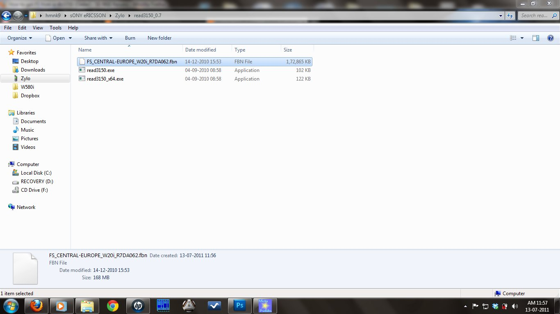
STEP 3: Drag and drop the .fbn file onto read3150.exe
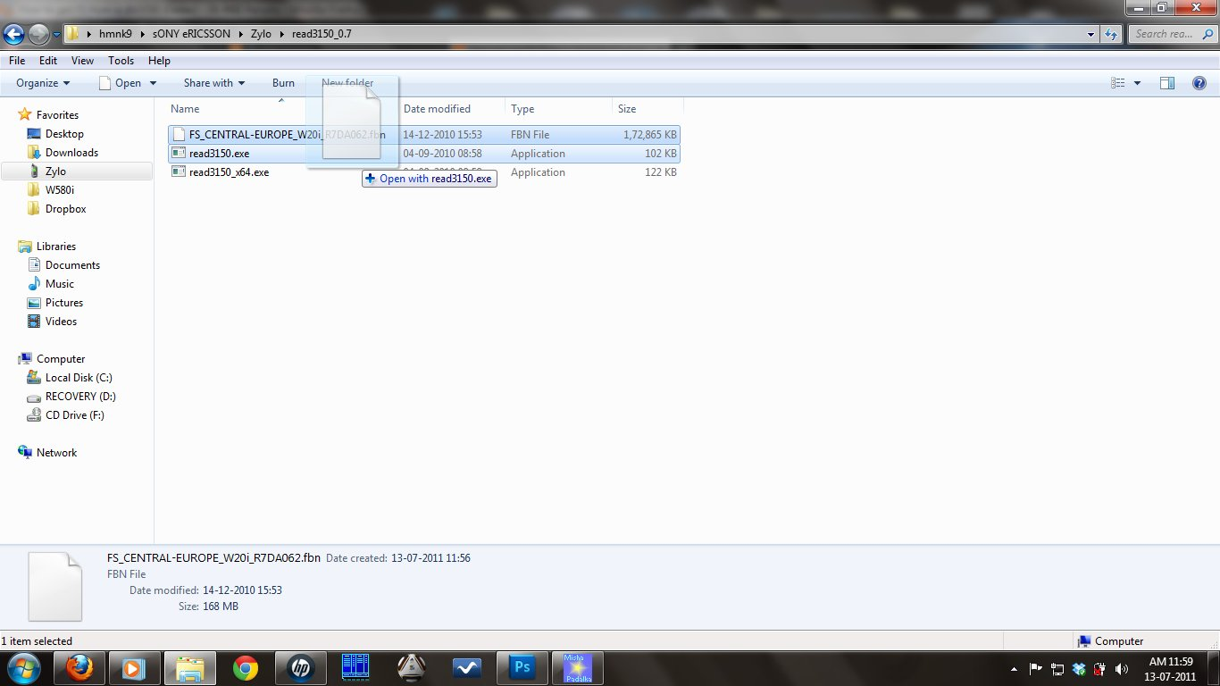
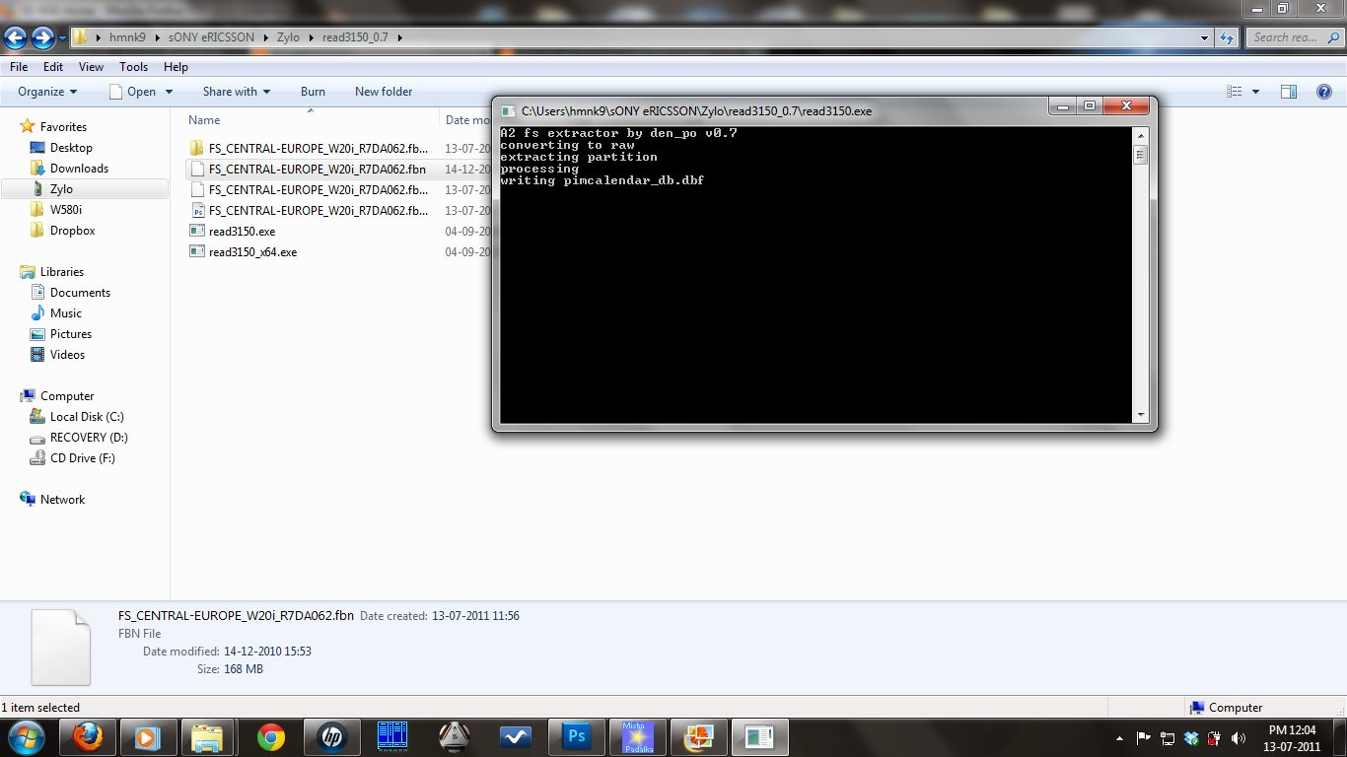
After read3150.exe has done it's work, you will have a folder containg the extracted FS of the phone(Which contains the .ic file loacted at \TPA\PRESET\SYSTEM\ICONS) + .dsk file.
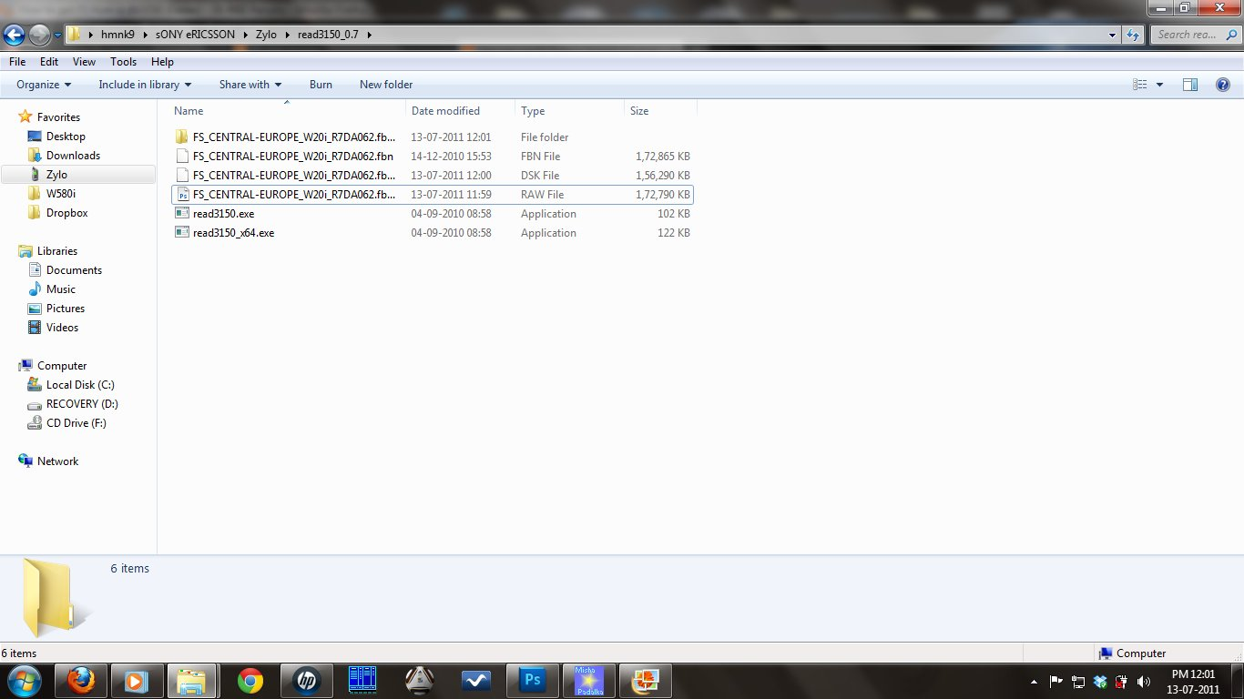
The same procedure is to be followed for extracting the MAIN (.mbn) of the phone.
You need to extract the .mbn file as you require the .dsk/phone_app.cxc file from there to load the names of the images into SE Image Tool.
STEP 4: Open SE Image Tool and follow the following steps:
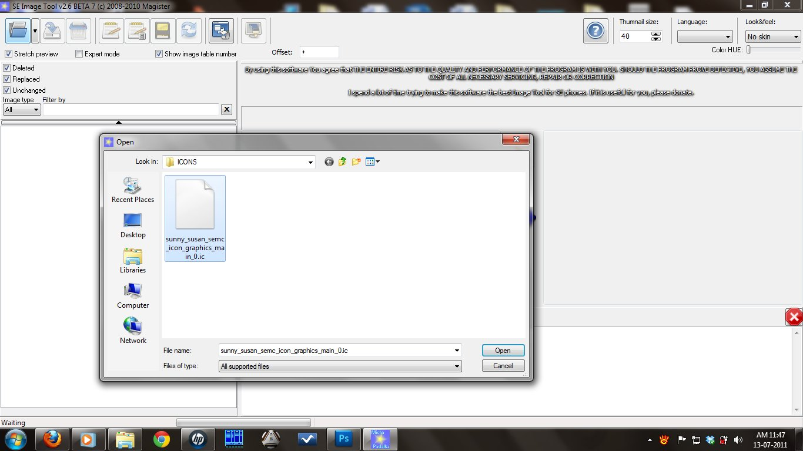
NOTE: For DB3350 phones, load the .dsk file but for DB32xx phones you need to load the phone_app.cxc file (Which is located in the folder created after extracting the .mbn file) instead of the .dsk file.
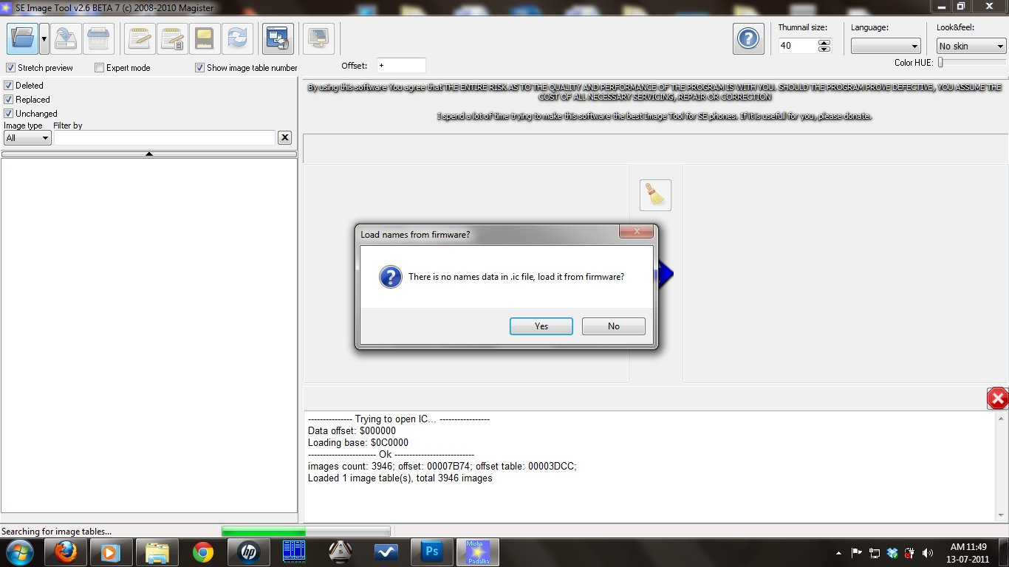
In the drop down list "Files of type" select "All files"...
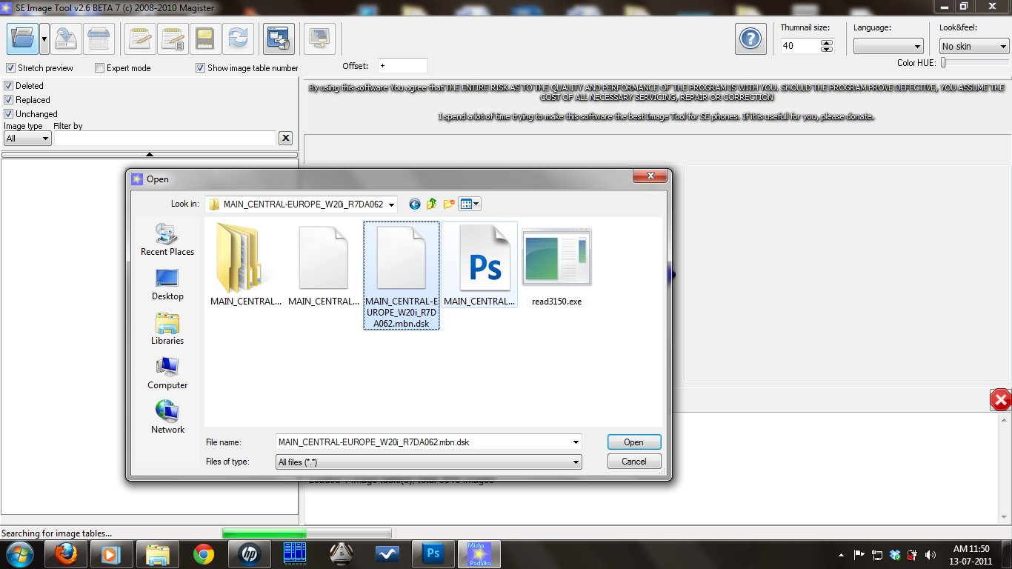
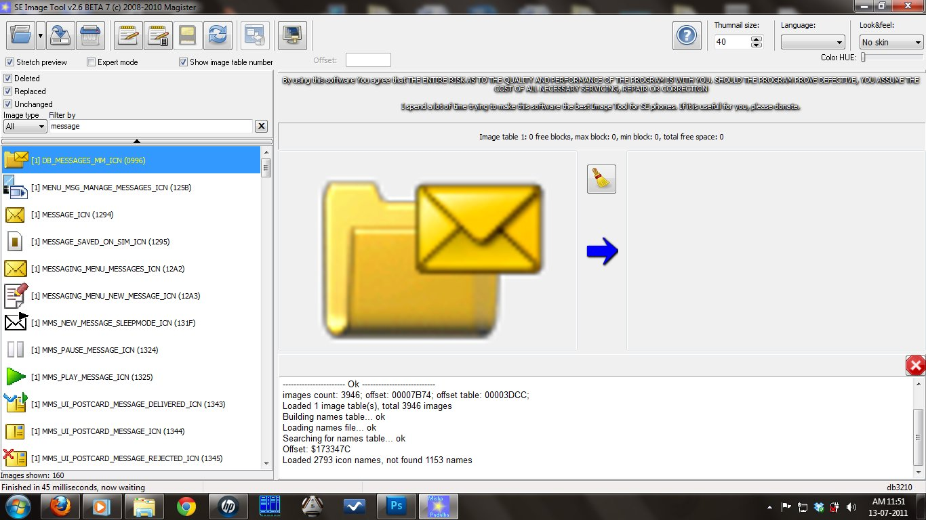
Hope this tutorial was helpful for you.
Thank you.

